Assignment No:8

Name : Rutuja Chaudhari
Class : CSAI-B (Batch 2)
PRN - 12311905
Roll No : 26

Title: Design and develop a website using Springboot.
Problem Statement: Design and develop a responsive website to prepare one semester result of VIT students using REACT, Springboot and MySQL/ MongoDB/Oracle. Take any four subjects with MSE Marks (30%) ESE Marks (70%).
Course Objective: To learn REST API based enterprise website development using REACT, Node JS, Spring Boot with different database technologies.
Course Outcome: Write Web API/RESTful API application programming interface to communicate with Springboot as a server side technology.
Tools Required: STS, MySql, Firefox/GoogleChrome
Theory:
1. Spring Boot
Spring Boot is a Java framework built on top of Spring that simplifies application development. It eliminates boilerplate code with auto-configuration. Spring Boot comes with an embedded server, making applications production ready out of the box. It supports web apps, REST APIs, microservices, security and seamless cloud deployment.
1.1 Why Spring Boot?
- Fast Development: Quickly build production ready apps with minimal configuration.
- Auto-Configuration: Reduces boilerplate code, you can focus on business logic.
- Microservices Friendly: Perfect for building and managing distributed systems.
- Seamless Integrations: Works easily with databases, security, messaging and cloud platforms.
- Wide Adoption: Backed by Spring ecosystem and used in real world enterprise applications.
1.2 Applications of Spring Boot
Following is the list of few of the great benefits of using Spring Boot Framework −
- POJO Based - Spring Boot enables developers to develop enterprise-class applications using POJOs. The benefit of using only POJOs is that you do not need an EJB container product such as an application server but you have the option of using only a robust servlet container such as Tomcat or some commercial product.
- Modular - Spring Boot is modular by nature. Even though the number of packages and classes are substantial, you have to worry only about the ones you need and ignore the rest.
- Integration with existing frameworks - Spring Boot does not reinvent the wheel, instead it truly makes use of some of the existing technologies like several ORM frameworks, logging frameworks, JEE, Quartz and JDK timers, and other view technologies.
- Testablity - Testing an application written with Spring Boot is very easy because environment-dependent code is moved into this framework. Furthermore, by using Java Bean style POJOs, it becomes easier to use dependency injection for injecting test data.
- Web MVC - Spring Boot's web framework is a well-designed web MVC framework, which provides a great alternative to web frameworks such as Struts or other over-engineered or less popular web frameworks.
- Central Exception Handling - Spring Boot provides a convenient API to translate technology-specific exceptions (thrown by JDBC, Hibernate, or JDO, for example) into consistent, unchecked exceptions.
- Lightweight - Lightweight IoC containers tend to be lightweight, especially when compared to EJB containers, for example. This is beneficial for developing and deploying applications on computers with limited memory and CPU resources.
- Transaction management - Spring Boot provides a consistent transaction management interface that can scale down to a local transaction (using a single database, for example) and scale up to global transactions (using JTA, for example).

2. Simple Project in STS
2.1 Project Structure
HelloWorldSpringBoot/
│
├── src/main/java/com/example/helloworld/
│ ├── HelloWorldApplication.java
│ └── HelloController.java
│
├── src/main/resources/
│ ├── application.properties
│
├── pom.xml

2.2 HelloWorldApplication.java
(Location: src/main/java/com/example/helloworld/HelloWorldApplication.java)
package com.example.helloworld;

import org.springframework.boot.SpringApplication;
import org.springframework.boot.autoconfigure.SpringBootApplication;

@SpringBootApplication
public class HelloWorldApplication {
public static void main(String[] args) {
SpringApplication.run(HelloWorldApplication.class, args);
System.out.println("🚀 Spring Boot Hello World Application Started!");
}
}

2.3 HelloController.java
(Location: src/main/java/com/example/helloworld/HelloController.java)
package com.example.helloworld;

import org.springframework.web.bind.annotation.GetMapping;
import org.springframework.web.bind.annotation.RestController;

@RestController
public class HelloController {

@GetMapping("/hello")
public String sayHello() {
return "Hello World from Spring Boot!";
}
}

2.4 application.properties
(Location: src/main/resources/application.properties)
server.port=8080
spring.application.name=HelloWorldSpringBoot

2.5 Run the Application
- Right-click HelloWorldApplication.java → Run As → Spring Boot App.
- Console will show:
🚀 Spring Boot Hello World Application Started!
Tomcat started on port(s): 8080
- Open browser: http://localhost:8080/hello

3. File Details
3. 1. pom.xml (HelloWorldSpringBoot/pom.xml)
- Defines the project as a Maven project.
- Lists dependencies like spring-boot-starter-web.
- Manages build plugins and Spring Boot version.

3. 2. HelloWorldApplication.java
(src/main/java/com/example/helloworld/HelloWorldApplication.java)
- The main entry point of the application.
- Annotated with @SpringBootApplication.
- Starts the Spring Boot application (embedded Tomcat server).
3.3. HelloController.java
( src/main/java/com/example/helloworld/HelloController.java)
- A REST controller (@RestController) that handles HTTP requests.
- Example:
  - URL /hello → returns "Hello World from Spring Boot!".
3.4. application.properties
( src/main/resources/application.properties)
- Stores configuration settings.
- Example:
  - Change port → server.port=8081.
  - Set application name → spring.application.name=HelloApp.
3.5. static/ (Optional)
( src/main/resources/static/)
- Stores static assets like CSS, JS, Images.
- Example: src/main/resources/static/style.css → accessible via http://localhost:8080/style.css.
3.6. templates/ (Optional)
( src/main/resources/templates/)
- Stores HTML pages (usually with Thymeleaf or JSP).
- Example: index.html here can be returned by a controller.

3.7. HelloWorldApplicationTests.java
( src/test/java/com/example/helloworld/HelloWorldApplicationTests.java)
- Auto-created JUnit test class.
- Used to test if the Spring context loads properly.

4. Spring Boot Annotations
Annotation | Meaning / Usage
1. @SpringBootApplication | Main entry point of a Spring Boot app. Combines @Configuration, @EnableAutoConfiguration, and @ComponentScan.
2. @RestController | Marks a class as a REST API controller (@Controller + @ResponseBody).
3. @Controller | Handles web requests (usually returns HTML views).
4. @GetMapping | Maps HTTP GET requests to a method.
5. @PostMapping | Maps HTTP POST requests to a method.
6. @PutMapping | Maps HTTP PUT requests to a method.
7. @DeleteMapping | Maps HTTP DELETE requests to a method.
8. @RequestMapping | General mapping for any HTTP request (GET/POST/PUT/DELETE).
9. @RequestParam | Extracts values from query parameters (e.g., /search?name=Tom).
10. @PathVariable | Extracts values from the URL path (e.g., /user/{id}).
11. @RequestBody | Maps JSON/XML request body to a Java object.
12. @ResponseBody | Sends return value of a method directly as HTTP response.
13. @Autowired | Injects (wires) dependencies automatically.
14. @Service | Marks a class as a service layer bean (business logic).
15. @Repository | Marks a class as a DAO/repository bean (database operations).
16. @Component | Generic annotation for Spring-managed beans.
17. @Entity | Defines a JPA entity (maps class to database table).
18. @Id | Marks a field as primary key in a JPA entity.
19. @GeneratedValue | Defines how the primary key is generated (AUTO, IDENTITY, SEQUENCE).
20. @Column | Maps a field to a database table column.

5. SQL (Structured Query Language)
Sql is a standard language used to manage and interact with databases. It allows you to store, retrieve, update, and delete data in a relational database.
MySQL is the most popular Open Source Relational SQL database management system. MySQL is a fast, easy-to-use RDBMS being used for many small and big businesses. MySQL is popular because:
- It is released under open source
- It handles a large subset of the functionality of the most expensive and powerful database packages, it uses standard form of the well-known SQL data language,
- works on many operating systems and with many languages including PHP, PERL, C, C++, JAVA, etc.
- MySQL works very quickly and works well even with large data sets and with PHP. MySQL supports large databases, up to 50 million rows or more in a table.
- The default file size limit for a table is 4GB, but we can increase this (if your operating system can handle it) to a theoretical limit of 8 million terabytes (TB)
5.1 Basic MySql Query

5.1.1 MySQL Connection
[root@host]# mysql -u root -p
Enter password:******

5.1.2 Create Database
mysql> CREATE DATABASE menagerie;

5.1.3 Selecting Database
mysql> USE menagerie
Database changed

5.1.4 Drop Database
mysql> DROP DATABASE TUTORIALS

5.1.5 Create MySQL Tables
Syntax:
CREATE TABLE table_name
(
column_name1 data_type(size),
column_name2 data_type(size),
....
);
Example:
CREATE TABLE Persons
(
PersonID int,
LastName varchar(255),
FirstName varchar(255),
Address varchar(255),
);

5.1.6 ALTER
Syntax:
ALTER TABLE table_name ADD column_name datatype;
ALTER TABLE table_name DROP COLUMN column_name;
ALTER TABLE table_name MODIFY COLUMN column_name datatype;
Example:
ALTER TABLE Persons ADD DateOfBirth date;
ALTER TABLE Persons ALTER COLUMN DateOfBirth int;
ALTER TABLE Persons DROP COLUMN DateOfBirth;

5.1.7 DROP
DROP TABLE table_name;
DROP DATABASE database_name;

Conclusion: Hence, we have successfully design and develop a responsive website to prepare one semester result of VIT students using Springboot and MySQL.

Source Code
Step 1: Create the Spring Boot project (STS wizard)
- In STS: File → New → Spring Starter Project.
- Fill:
  - Name: ty-application
  - Group: com.example
  - Artifact: ty-application (or marks-certificate)
  - Package: com.example.demo
  - Type: Maven, Packaging: Jar, Java: 17 (or your version)
- Click Next → in Dependencies choose:
  - Spring Web
  - Thymeleaf
  - Spring Data JPA
  - MySQL Driver
  - (Optional) Spring Boot DevTools
- Click Finish.
Step 2: Create Java package structure
You need packages for model, controller, repository, and the main app.
- Expand src/main/java.
- Create new package com.example.demo.model, com.example.demo.controller, com.example.demo.repository.
Step 3: Create Java files (classes)
- src/main/java/com/example/demo/TyApplication.java
- src/main/java/com/example/demo/model/StudentResult.java
- src/main/java/com/example/demo/repository/StudentResultRepository.java
- src/main/java/com/example/demo/controller/ResultController.java
Step 4: Create Thymeleaf templates (HTML)
Put these files in src/main/resources/templates/:
- index.html — the marks input form.
- certificate.html — the generated certificate page.
Step 5: Create MySQL database
CREATE DATABASE studentdb;

Project structure (files & locations)
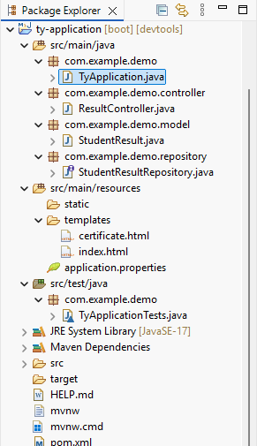

File and Source Code
pom.xml
<!-- pom.xml -->
<project xmlns="http://maven.apache.org/POM/4.0.0"
xmlns:xsi="http://www.w3.org/2001/XMLSchema-instance"
xsi:schemaLocation="http://maven.apache.org/POM/4.0.0
http://maven.apache.org/maven-v4_0_0.xsd">
<modelVersion>4.0.0</modelVersion>
<groupId>com.example</groupId>
<artifactId>ty-application</artifactId>
<version>0.0.1-SNAPSHOT</version>
<packaging>jar</packaging>

<name>ty-application</name>
<description>Spring Boot App - CGPA calculator and certificate</description>

<parent>
<groupId>org.springframework.boot</groupId>
<artifactId>spring-boot-starter-parent</artifactId>
<version>3.2.0</version>
<relativePath/> <!-- lookup parent from repository -->
</parent>

<properties>
<java.version>17</java.version>
</properties>

<dependencies>
<!-- Web + Thymeleaf -->
<dependency>
<groupId>org.springframework.boot</groupId>
<artifactId>spring-boot-starter-thymeleaf</artifactId>
</dependency>
<dependency>
<groupId>org.springframework.boot</groupId>
<artifactId>spring-boot-starter-web</artifactId>
</dependency>

<!-- JPA + MySQL -->
<dependency>
<groupId>org.springframework.boot</groupId>
<artifactId>spring-boot-starter-data-jpa</artifactId>
</dependency>
<dependency>
<groupId>com.mysql</groupId>
<artifactId>mysql-connector-j</artifactId>
<scope>runtime</scope>
</dependency>

<!-- Optional: devtools for hot reload in development -->
<dependency>
<groupId>org.springframework.boot</groupId>
<artifactId>spring-boot-devtools</artifactId>
<optional>true</optional>
</dependency>
</dependencies>

<build>
<plugins>
<plugin>
<groupId>org.springframework.boot</groupId>
<artifactId>spring-boot-maven-plugin</artifactId>
</plugin>
</plugins>
</build>
</project>
VitresultApplication.java

package com.example.vitresult;

import org.springframework.boot.SpringApplication;
import org.springframework.boot.autoconfigure.SpringBootApplication;

@SpringBootApplication
public class VitresultApplication {
public static void main(String[] args) {
SpringApplication.run(VitresultApplication.class, args);
}
}

StudentResult.java

package com.example.vitresult.model;

import jakarta.persistence.Entity;
import jakarta.persistence.GeneratedValue;
import jakarta.persistence.GenerationType;
import jakarta.persistence.Id;

@Entity
public class StudentResult {
@Id
@GeneratedValue(strategy = GenerationType.IDENTITY)
private Long id;

private String studentName;
private double mse1, mse2, mse3, mse4;
private double ese1, ese2, ese3, ese4;

public double getTotalMarks() {
return (mse1 * 0.3 + ese1 * 0.7)
+ (mse2 * 0.3 + ese2 * 0.7)
+ (mse3 * 0.3 + ese3 * 0.7)
+ (mse4 * 0.3 + ese4 * 0.7);
}

public double getCgpa() {
return (getTotalMarks() / 400) * 10;
}

// Getters and Setters
public Long getId() { return id; }
public void setId(Long id) { this.id = id; }

public String getStudentName() { return studentName; }
public void setStudentName(String studentName) { this.studentName = studentName; }

public double getMse1() { return mse1; }
public void setMse1(double mse1) { this.mse1 = mse1; }

public double getMse2() { return mse2; }
public void setMse2(double mse2) { this.mse2 = mse2; }

public double getMse3() { return mse3; }
public void setMse3(double mse3) { this.mse3 = mse3; }

public double getMse4() { return mse4; }
public void setMse4(double mse4) { this.mse4 = mse4; }

public double getEse1() { return ese1; }
public void setEse1(double ese1) { this.ese1 = ese1; }

public double getEse2() { return ese2; }
public void setEse2(double ese2) { this.ese2 = ese2; }

public double getEse3() { return ese3; }
public void setEse3(double ese3) { this.ese3 = ese3; }

public double getEse4() { return ese4; }
public void setEse4(double ese4) { this.ese4 = ese4; }
}

StudentRepository.java

package com.example.vitresult.repository;

import org.springframework.data.jpa.repository.JpaRepository;
import com.example.vitresult.model.StudentResult;

public interface StudentRepository extends JpaRepository<StudentResult, Long> {}

ResultController.java

package com.example.vitresult.controller;

import com.example.vitresult.model.StudentResult;
import com.example.vitresult.repository.StudentRepository;
import org.springframework.beans.factory.annotation.Autowired;
import org.springframework.web.bind.annotation.*;

import java.util.List;

@RestController
@CrossOrigin(origins = "http://localhost:3000")
@RequestMapping("/api/results")
public class ResultController {

@Autowired
private StudentRepository repo;

@PostMapping("/add")
public StudentResult addResult(@RequestBody StudentResult result) {
repo.save(result);
return result;
}

@GetMapping("/all")
public List<StudentResult> getAll() {
return repo.findAll();
}
}

application.properties
spring.datasource.url=jdbc:mysql://localhost:3306/studentdb
spring.datasource.username=root
spring.datasource.password=root

spring.jpa.hibernate.ddl-auto=update
spring.jpa.show-sql=true
spring.jpa.properties.hibernate.dialect=org.hibernate.dialect.MySQLDialect
server.port=8080

Certificate.js
import React from "react";
import "./Certificate.css";

function Certificate({ data, setCertificateData }) {
const handlePrint = () => {
window.print();
};

return (
<div className="certificate-container mt-4 p-5 shadow-lg">
<div className="certificate-border">
<h2 className="text-center text-primary">Vishwakarma Institute of Technology, Pune</h2>
<h4 className="text-center">Semester Result Certificate</h4>
<hr />

<p><strong>Student Name:</strong> {data.studentName}</p>
<p><strong>Roll No:</strong> {data.rollNo}</p>

<table className="table table-bordered mt-3">
<thead className="table-light">
<tr>
<th>Subject</th>
<th>MSE (30%)</th>
<th>ESE (70%)</th>
<th>Total (100%)</th>
</tr>
</thead>
<tbody>
{[1, 2, 3, 4].map((i) => (
<tr key={i}>
<td>Subject {i}</td>
<td>{data[`mse${i}`]}</td>
<td>{data[`ese${i}`]}</td>
<td>{((data[`mse${i}`] * 0.3) + (data[`ese${i}`] * 0.7)).toFixed(2)}</td>
</tr>
))}
</tbody>
</table>

<h5 className="text-end text-success">
CGPA: {data.cgpa ? data.cgpa.toFixed(2) : "8.5"}
</h5>

<p className="text-center mt-4">
This is a computer-generated result. No signature required.
</p>

<div className="text-center mt-3">
<button onClick={handlePrint} className="btn btn-primary me-2">
Print Certificate
</button>
<button onClick={() => setCertificateData(null)} className="btn btn-secondary">
Back
</button>
</div>
</div>
</div>
);
}

export default Certificate;

Step 6: Run DemoApplication as Spring Boot App.
Step 7 : Open browser: http://localhost:8080/

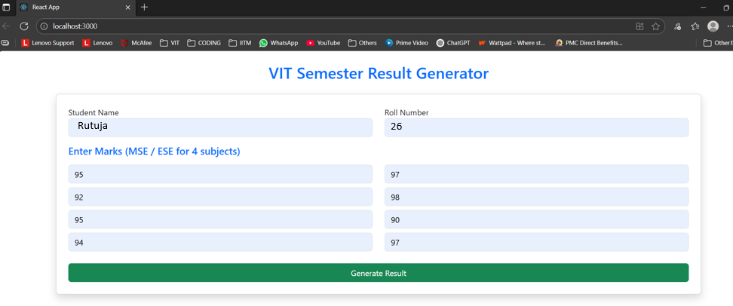

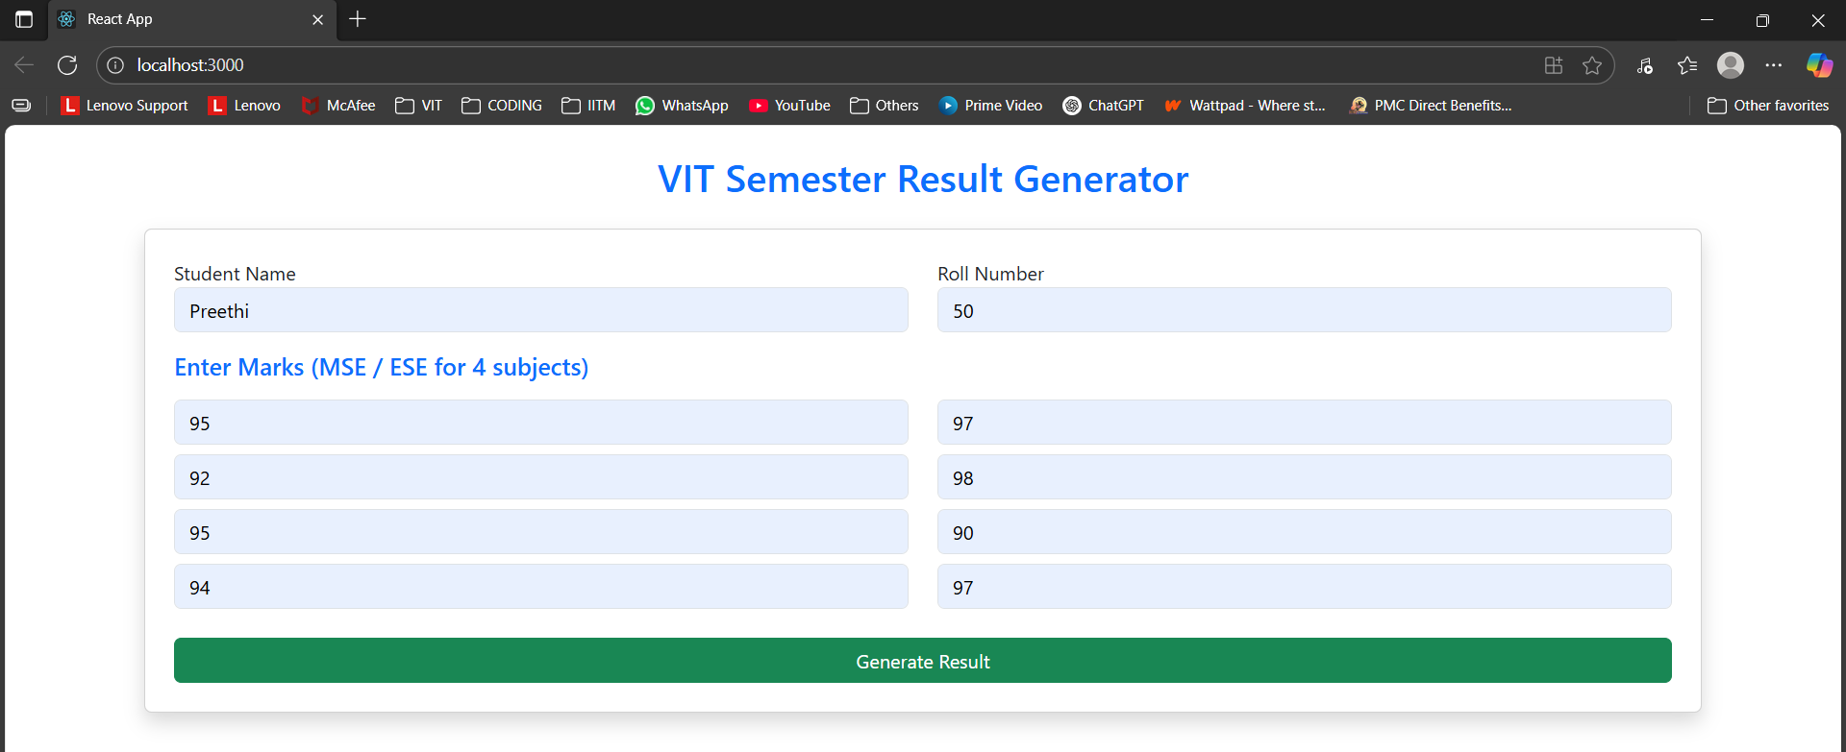
26
Rutuja
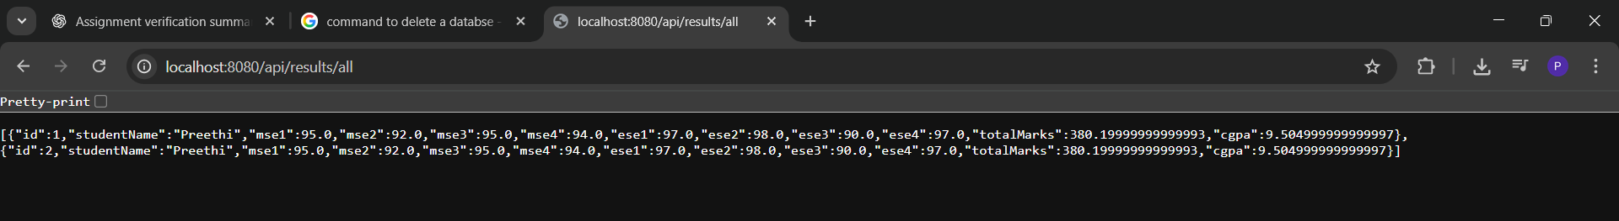
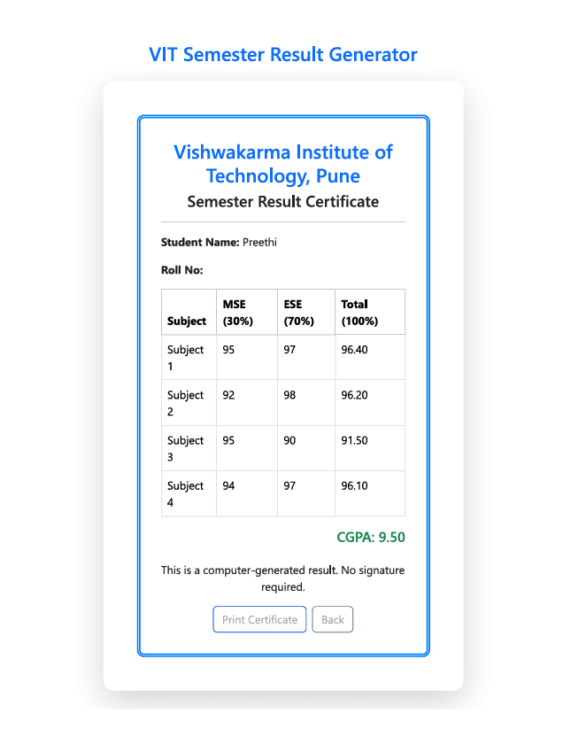
26
Rutuja

